Ubuntu Server 22.04.03

jokin

ssh

ssh jokin@172.20.114.90

**sudo apt-get update -y && sudo apt-get upgrade -y**

**sudo apt-get install apache2 -y**

**sudo systemctl start apache2**

**sudo systemctl enable apache2**

**sudo systemctl status apache2**

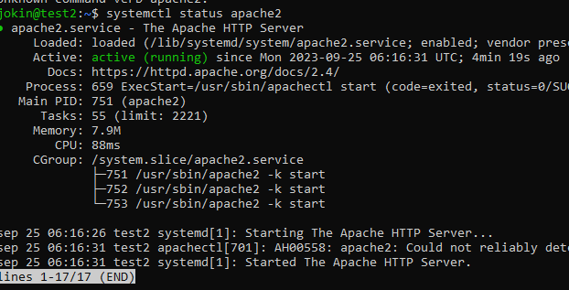

<http://172.20.114.90>

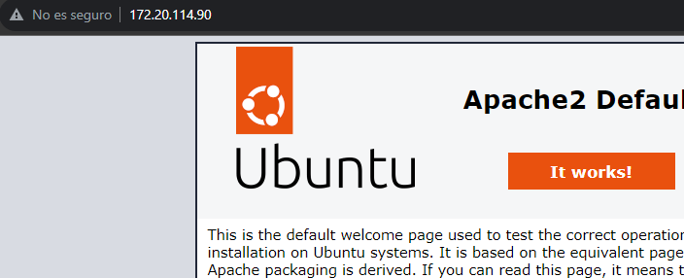

**cd /var/www/html**

**index.html**

**style.css**

**script.js**

**sudo systemctl restart apache2**

